Team members:

Sriram Vellangallor Subramanian 1209270383

Karumpudi Ramakrishna Reddy 1209319770

Dhiraj Gurkhe 1209305002

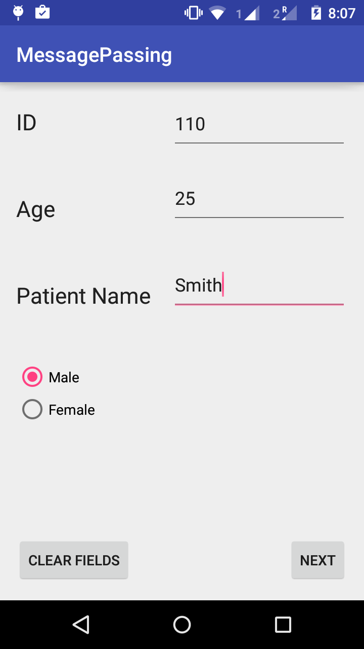 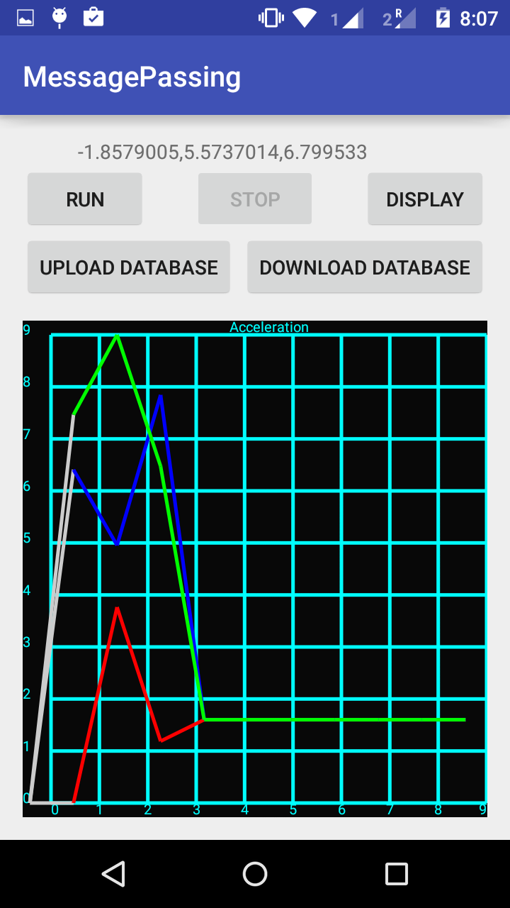

Figure 1 First screen: Input patient data Figure Second screen: Display graph

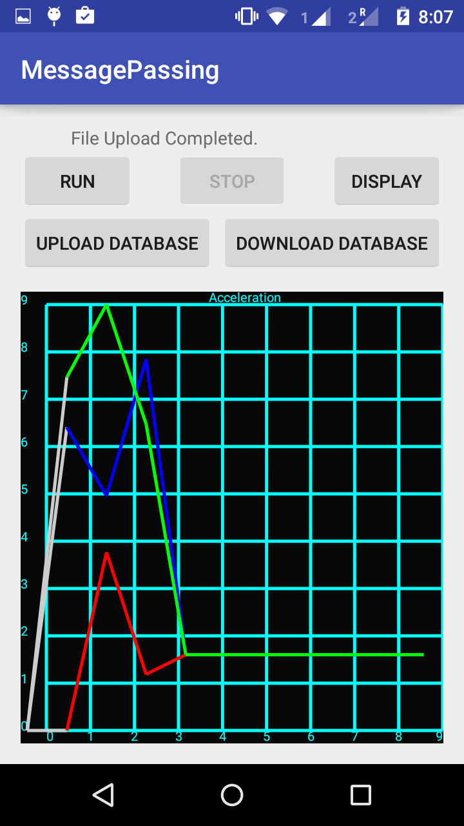 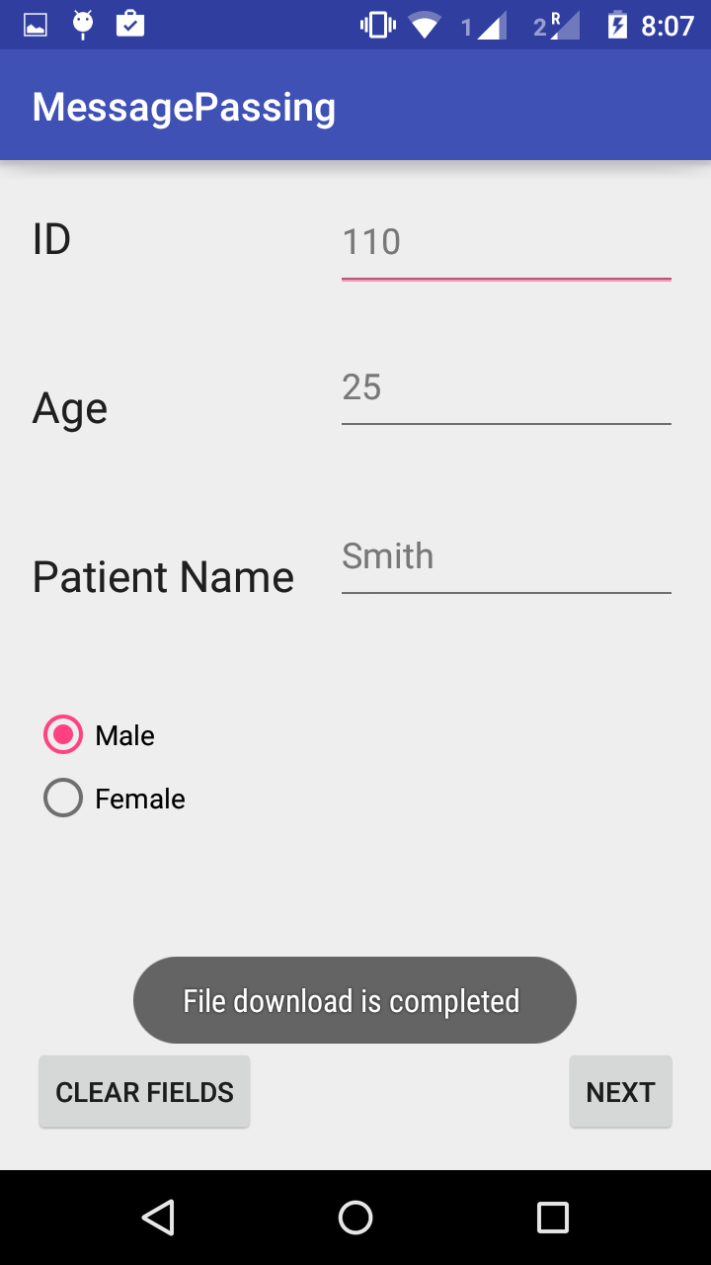

Figure File uploaded Figure File downloaded